Final Report for Frontiers in GIS

Map identification and classification based on projection and region

using Machine Learning methods

Jialin Li

The Ohio State University

**Map identification and classification based on projection and region**

**using Machine Learning methods**

**1. Introduction**

Artificial Intelligence (AI) has been applied to plenty of fields to solve the problems in different areas, aiming at making machine act as human beings. AI has been commonly used in almost every field in our daily life, for example, self-driving car, speech recognition, game playing and robotics. Several Artificial Intelligence-based techniques have been applied to improve Intelligence Transportation Systems for three main areas: vehicle control, traffic control and prediction as well as road safety and accident prediction (Machin et al., 2018). Silver et al. (2017) trained a neural network by reinforcement learning without human data, guidance or domain knowledge beyond game rules to predict AlphaGo’s own move selections which became the first program to defeat a world champion in the game of Go. Sengorur, Koklu and Ates (2015) used self-organizing map- artificial neural networks (SOM-ANNs) to evaluate the high-low flow period correlations in terms of water-quality parameters. And the SOM supported by ANN, is applied to provide a nonlinear relationship between input and output variables in order to determine the most significant parameters in each group. Seo et al. in 2015 developed and applied two hybrid models for daily water level forecasting and investigate their accuracy. The two hybrid models are wavelet-based artificial neural network (WANN) and wavelet-based adaptive neuro-fuzzy inference system (WANFIS).

However, there is little application of AI in cartography or the process of map making. Some questions in cartography can be possibly solved by methods in AI. If an image is given to AI, is it able to tell us some information about this image? I think AI can answer these questions as follows. First, Can AI tell whether this image is a map? Second, which region is the map about? Then, what is the projection used in this map? Next, can we extract the point, line and polygon features and their attribute value for further analysis? Last but not least, is this map a good map from the perspectives of color use, label placement and so on?

In this project, I focused on the first questions as my research question: 1. Can AI figure out whether the given image is a map? 2. If this image is a map, is AI able to find which region this map is about? 3. What is the projection used in this map? The three research questions are object detection and classification problems, which can be solved by some machine learning methods. The process of find solutions to the questions is optimization of parameters in the methods in essence. In this project, I used each of the three machine learning methods, MultiLayer Perceptions (MLPs), Support vector machines (SVMs) and Convolutional Neural Networks (CNNs) to solve map identification, region classification and projection classification problems.

In 2016, He et al. developed a system for automatically mapping and inspecting power line components using CNN-based object detection and classification models. This system is capable of mapping basic power components including poles, toppads, crossarms in insulators. Hughes and Salathe in 2015 and Mohanty et al. in 2016 utilized 54306 images to train DCNN (AlexNet and GoogLeNet architectures) to identify 26 diseases from 14 distinct crop species. According to the assessment metric F1 score, GoogLeNet outperforms AlexNet. VGG CNN was used by Ferentinos (2018) to work on the same Plant Village dataset and the success rate of identifying plant stress was very high. The results indicated that the model performance was better when original images were used and the use of preprocessed images would lead to significantly reduced computational time. Oh et al. (2013) applied Differential Evolution (DE) to optimize the parameters of a Radial Basis Function Neural Network (RBFNN) and also for feature selection of PCA and Linear Discriminant analysis (LDA) features. Ashok et al. (2016) compared feature selection methods for diagnosis of cervical cancer using a support vector machine (SVM) classifier. Feature selection was achieved using mutual information. Sequential forward search, sequential floating forward search and random subset feature selection methods. An accuracy of 98.5% was obtained using the sequential floating forward selection method.

**2. Methodology**

In this study, I first used MLPs, SVMs and CNNs to identify whether an image is a map. Then I also used these methods to classify the regions and the projections of the map. In this section, I will briefly introduce these three machine learning methods.

**2.1 Multiplayer perceptrons (MLPs)**

MLPs here mean the traditional multi-layer neural networks, which is the basis of deep neural networks including CNNs. MLPs have been successfully used for image recognition in many fields (Sibanda & Pretorius, 2011).

MLPs are a class of feedforward artificial neural networks, the general architecture of MLPs can be shown in Fig. 1 below. Backpropagation, which is an important supervised learning technique in artificial neural networks, is used in MLPs for the process of training parameters.

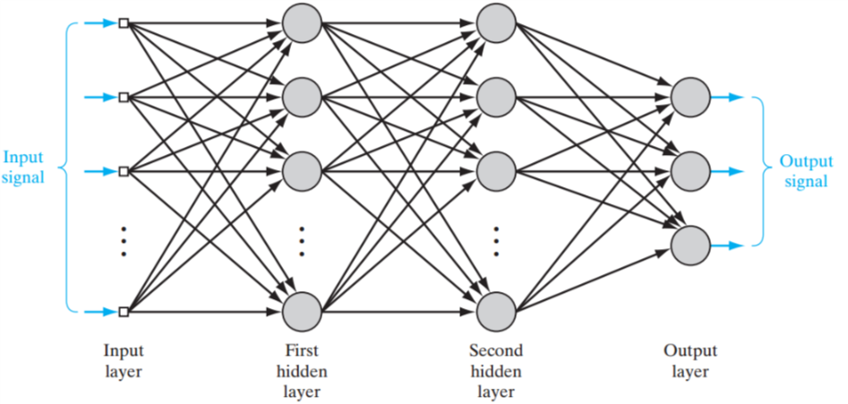

Fig.1 General architecture of MLPs

**2.2 Support vector machines (SVMs)**

SVMs are one of the most effective machine learning algorithms in object detection and classification problems in various fields (Oleszkiewicz et al., 2016). They are supervised learning models with associated learning algorithm. For a linear separable classification task, there are infinitely many separating hyperplanes as shown in Fig.2 below. SVMs aim at finding the optimal separating hyperplanes. For nonlinearly separable case, SVMs map the input space onto a high-dimensional feature space. The structure of SVMs is shown below in Fig.3. The reason is that according to Cover’s theorem, a complex classification problem, cast in a high-dimensional space nonlinearly, is more likely to be linearly separable than in the low-dimensional input space. For example, input patterns can not be separated in 2-dimensional space, but they can be separable in 3-dimensional space as shown in Fig.4.

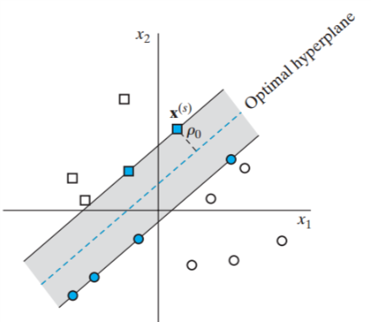

Fig.2 Linear separable classification task

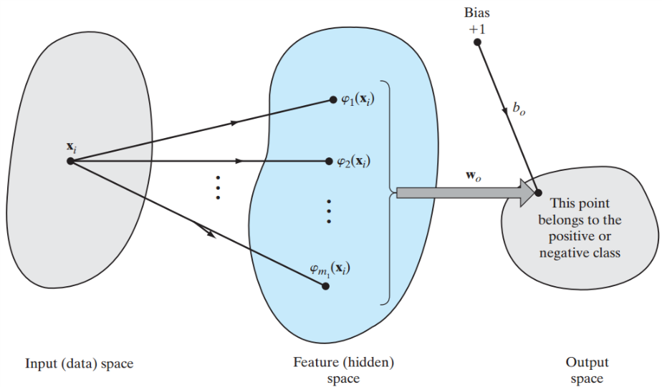

Fig.3 Structures of SVMs for non-linear classification

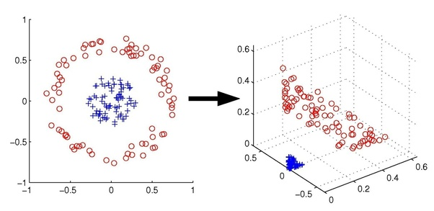

Fig.4 Example of separation of patterns in high-dimensional space

**2.3 Convolutional neural networks**

CNNs have been proved highly effective in large-scale image recognition and object detection (Zhu et al.,2017). CNNs are a class of deep, feed-forward artificial neural networks. Traditional MLPs cannot go deeper because of vanishing or exploding gradient problem. CNNs can solve the problems of traditional MLPs by reducing the number of free parameters and allowing the network to be deeper with fewer parameters. CNNs are the most commonly applied method for analyzing visual imagery. An example of the network architecture of CNNs is shown in Fig.5 below.

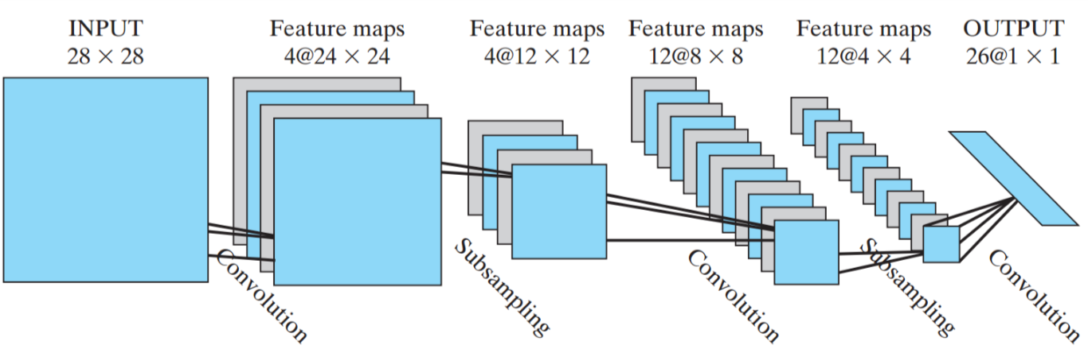

Fig.5 An example of the architecture of CNNs

**2.4 Transfer Learning (Jialin Li)**

**2.4.1 GoogLeNet (Ziyu Guo)**

**2.4.2 VGG16 (Jialin Li)**

**2.4.3 VGG19 (Luyu Liu)**

**3. Experiment Preparation**

**3.1 Data collection (Rui Li)**

Generated images

Images from the Internet

**3.2 Libraries and tools used (Jialin Li)**

In our experiment, I used MLPs, SVMs and CNNs to solve the mentioned problem of map identification and classification. Keras package in Python is used in this project to accomplish MLPs and CNNs. Keras package is a commonly used package to implement different kinds of neural networks. It can run on top of Tensorflow, designed to enable fast experimentation. Tensorflow is currently the most popular package for deep learning developed by Google. And for SVMs, I used a package called libsvm in Python to implement four kinds of SVMs: Linear kernel SVM, RBF kernel SVM, Polynomial kernel SVM and Sigmoid kernel SVM. As for the parameters in these SVMs, cross validation is used to select the best fitting parameters. For parameter setting of CNNs, I started from an empirical model which has been proved the best parameter setting of CNNs for classical digital hand writing recognition problem, and then changed some of the parameters in CNNs to get the best results in our case. Because the initial parameter settings are different for each of the three methods and randomly selected images for training and testing are also different, I conducted 10 sets of experiments for each of each parameter setting of the three methods and calculate the average testing accuracy for each parameter setting.

Transfer learning

Google Colabotory

**4. Experiment and Discussion**

**4.1 Maps Identification**

In this set of experiments, there are totally 140 images used, in which 80 images are maps and 60 images are non-map. Among the 140 images, 120 images are randomly selected for training and the remaining 20 images are used for testing. In map identification, the output should be whether this image is a map. So, it is a binary classification problem. For simplification, the maps I used here are all world maps.

For MLPs and CNNs, I compared the average results between different number of hidden layers. Because the performance difference between MLPs and CNNs with different number of hidden layers is significantly large, difference but between MLPs and CNNs with same number of hidden layers is not obvious. The testing accuracy results are shown in Table.1 and Fig. 7 below. From the results, we can find that the best results are from MLPs with 3 hidden layers. The architecture of the best result is 600-200-100-1, which means that there are 600 nodes in the first hidden layer, 200 nodes in the second hidden layer and 100 nodes within the third hidden layer. For this setting, the training accuracy is 0.96 and testing accuracy is 0.97.

Table.1 Testing accuracy results of MLPs

|  |  |  |
| --- | --- | --- |
| **# Hidden Layers** | **Training Acc** | **Testing Acc** |
| 2 | 0.88 | 0.79 |
| 3 | 0.91 | 0.90 |
| 4 | 0.41 | 0.49 |

Fig. 7 Testing accuracy results of MLPs

For SVMs, the testing results of four kinds of classification kernel were compared in this experiment. The results are shown in Table.2 and Fig. 8 below. According the results, Linear kernel and Polynomial kernel SVMs outperforms the other two.

Table.2 Testing accuracy results of SVMs

|  |  |  |
| --- | --- | --- |
| **Kernel Function** | **Training Acc** | **Testing Acc** |
| Linear | 1 | 0.87 |
| RBF | 0.57 | 0.63 |
| Polynomial | 1 | 0.92 |
| sigmoid | 0.58083 | 0.565 |

Fig. 8 Testing accuracy results of SVMs

As for CNNs, the best results are from CNNs with 2 convolutional layers. The best training accuracy could reach 1, and testing accuracy can reach 0.96. The general results of CNNs for map identification is shown in Table.3 and Fig.9 below.

Table.3 Testing accuracy results of CNNs

|  |  |  |
| --- | --- | --- |
| **# Hidden Layers** | **Training Acc** | **Testing Acc** |
| 2 | 0.99 | 0.93 |
| 3 | 0.99 | 0.92 |
| 4 | 0.94 | 0.90 |

Fig. 9 Testing accuracy results of CNNs

Comparing the experiment results of the three methods, we can find that all of the three methods can get relatively good results. I think that is because the difference between map images and non-map images is big enough for all of the three methods classify them correctly. And CNNs with 2 convolutional layers got the best results. The testing accuracy of best result we got is 100%. The images and corresponding predicted label are shown as follows:

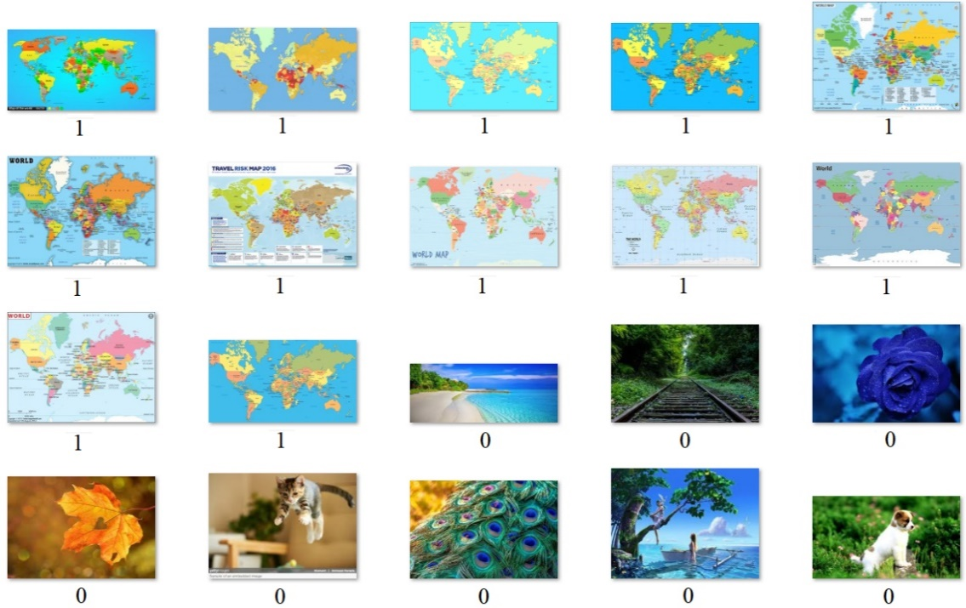

Fig.10 The images and corresponding predicted label

**4.2 Region classification**

In this set of experiments, there are totally 160 images used, in which 40 images are for each of the four regions: world, China, South Korea and the US. Among the 160 images, 140 images are randomly selected for training and the remaining 20 images are used for testing. In region classification, the output should be which region this map is about. So, it is a 4-class classification problem. Some example images for the four regions are shown as follows:

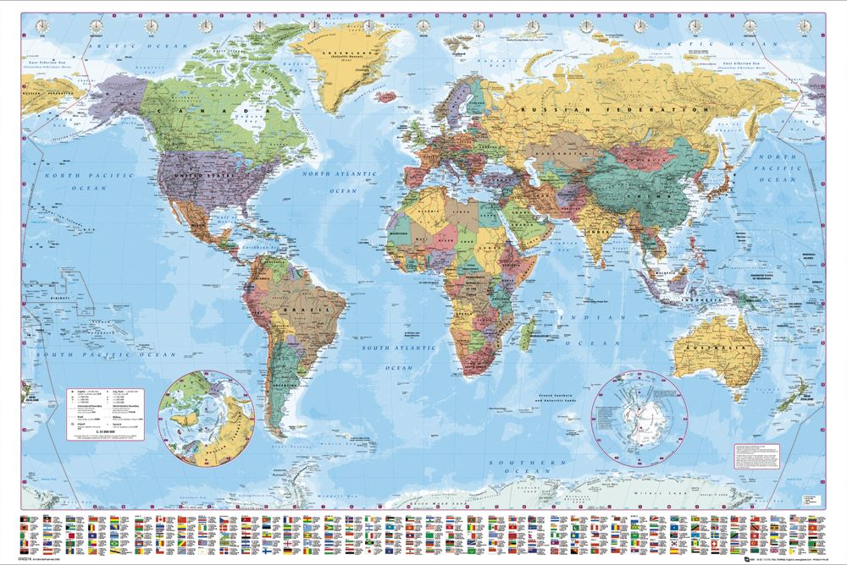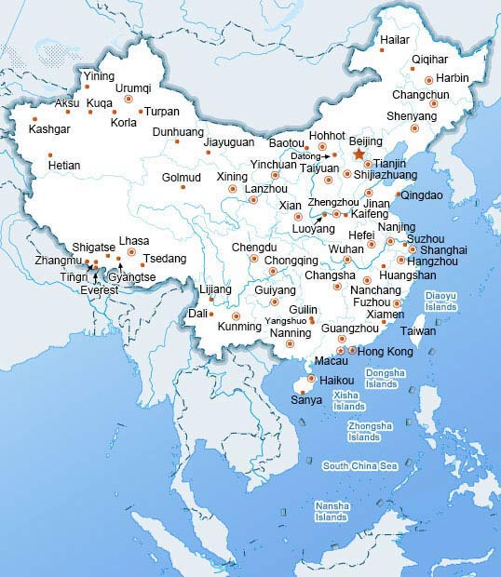

(a)World map (b)China map

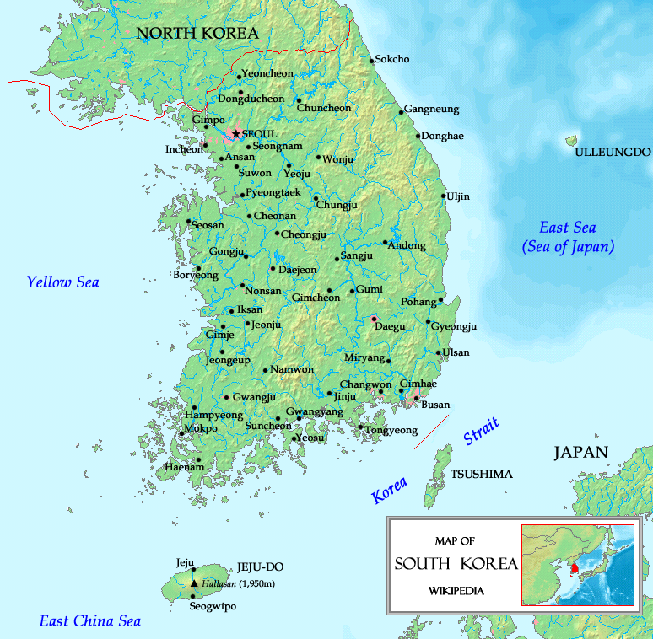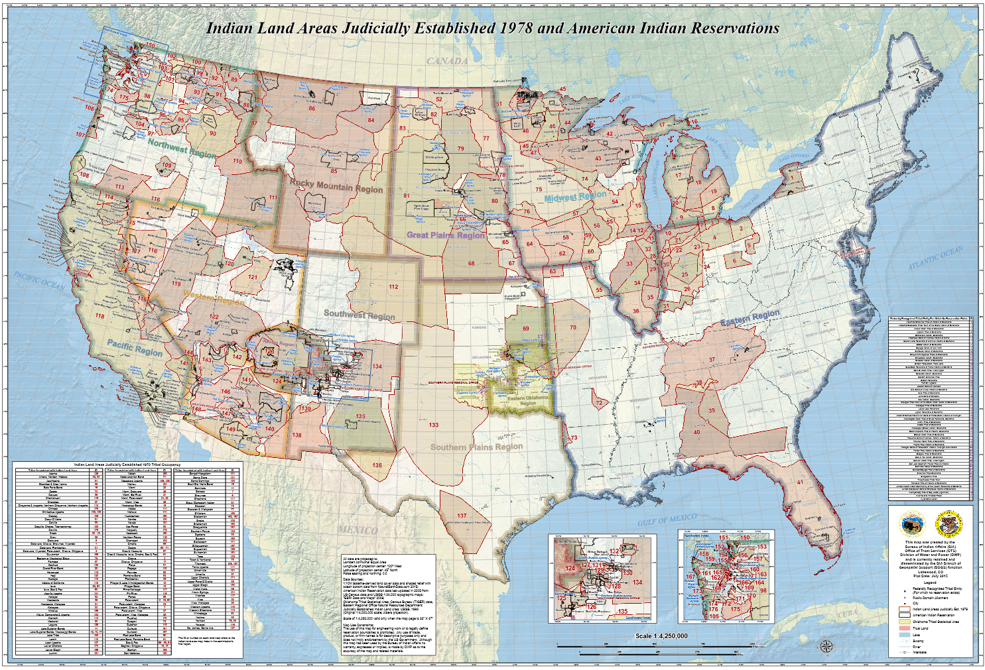

(c)South Korea map (d)US map

Fig.11 Examples of maps about four regions

The testing accuracy results of MLPs are shown in Table.4 and Fig.12 below. From the results, we can find that both training accuracy and testing accuracy of the results are all very bad for MLPs with different number of hidden layers. The accuracies are all about 0.25, which is the probability for one class in the four. The predicted value is all for one class. MLPs are not powerful enough to tell the difference between distinct regions.

Table.4 Testing accuracy results of MLPs

|  |  |  |
| --- | --- | --- |
| **# Hidden Layers** | **Training Acc** | **Testing Acc** |
| 2 | 0.25 | 0.25 |
| 3 | 0.25 | 0.25 |
| 4 | 0.25 | 0.26 |

Fig. 12 Testing accuracy results of MLPs

For SVMs, the testing results of four kinds of classification kernel were compared in this experiment. The results are shown in Table.5 and Fig.13 below. According to the results, Linear kernel and Polynomial kernel SVMs significantly outperforms the other two. They can classify the four classes with satisfactory results, but the other two’s results are very bad. That means that the inner function of region classification fits linear and polynomial kernels well, but it cannot fit RBF and Sigmoid kernels. And we can also find that the training accuracy of RBF kernel is good, but the testing accuracy is very poor. So, the RBF kernel overfits the inner function of region classification.

Table.5 Testing accuracy results of SVMs

|  |  |  |
| --- | --- | --- |
| **Kernel Function** | **Training Acc** | **Testing Acc** |
| Linear | 1 | 0.91 |
| RBF | 0.90 | 0.22 |
| Polynomial | 1 | 0.91 |
| sigmoid | 0.27 | 0.12 |

Fig. 13 Testing accuracy results of SVMs

As for CNNs, the best results are from CNNs with 2 convolutional layers. The best training accuracy could reach 1, and testing accuracy can reach 0.92. The general results of CNNs for map identification is shown in Table.6 and Fig.14 below. The CNNs can also get results with high testing accuracy.

Table.6 Testing accuracy results of CNNs

|  |  |  |
| --- | --- | --- |
| **# Hidden Layers** | **Training Acc** | **Testing Acc** |
| 2 | 1 | 0.92 |
| 3 | 1 | 0.87 |
| 4 | 0.70 | 0.55 |

Fig.14 Testing accuracy results of CNNs

Comparing the experiment results of the three methods, we can find that SVMs and CNNs can also get very good classification results with some parameter settings but MLPs cannot get good results. I think that is because the difference between map images of different region is much smaller than the difference between map and non-map images. In this case, MLPs cannot tell the difference and get good classification results. And CNNs with 2 convolutional layers can still get the best results. The testing accuracy of best result we got is 100%. The images and corresponding predicted label are shown as follows:

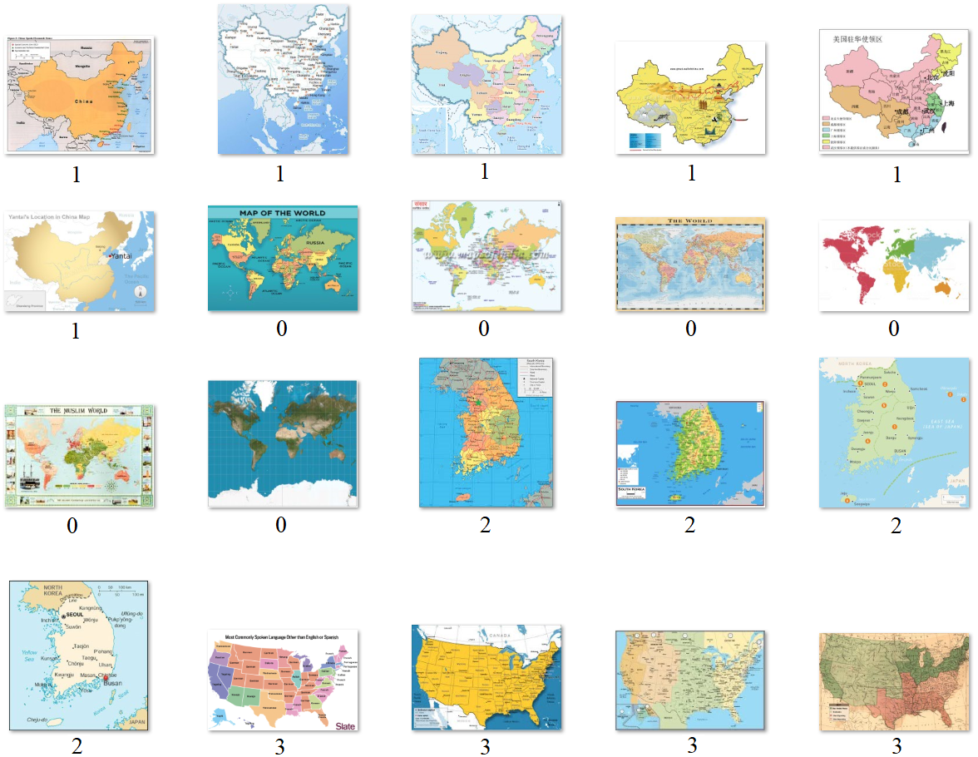

Fig.15 The images and corresponding predicted label

**4.3 Region classification with transfer learning**

**4.3.1 GoogLeNet (Ziyu Guo)**

**Parameter setting**

**Experiment results**

**Discussion**

**4.3.2 VGG16 (Jialin Li)**

**Parameter setting**

**Experiment results**

**Discussion**

**4.3.3 VGG19 (Luyu Liu)**

**Parameter setting**

**Experiment results**

**Discussion**

**4.4 Projection classification**

In this set of experiments, there are totally 160 images used, in which 40 images are for each of the four projections: Equirectangular, Mercator, Miller and Robinson projection. Among the 160 images, 140 images are randomly selected for training and the remaining 20 images are used for testing. In projection classification, the output should be which projection this map is using. So, it is a 4-class classification problem. Some example images for the four projections are shown as follows:

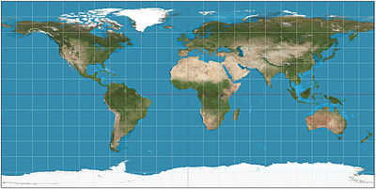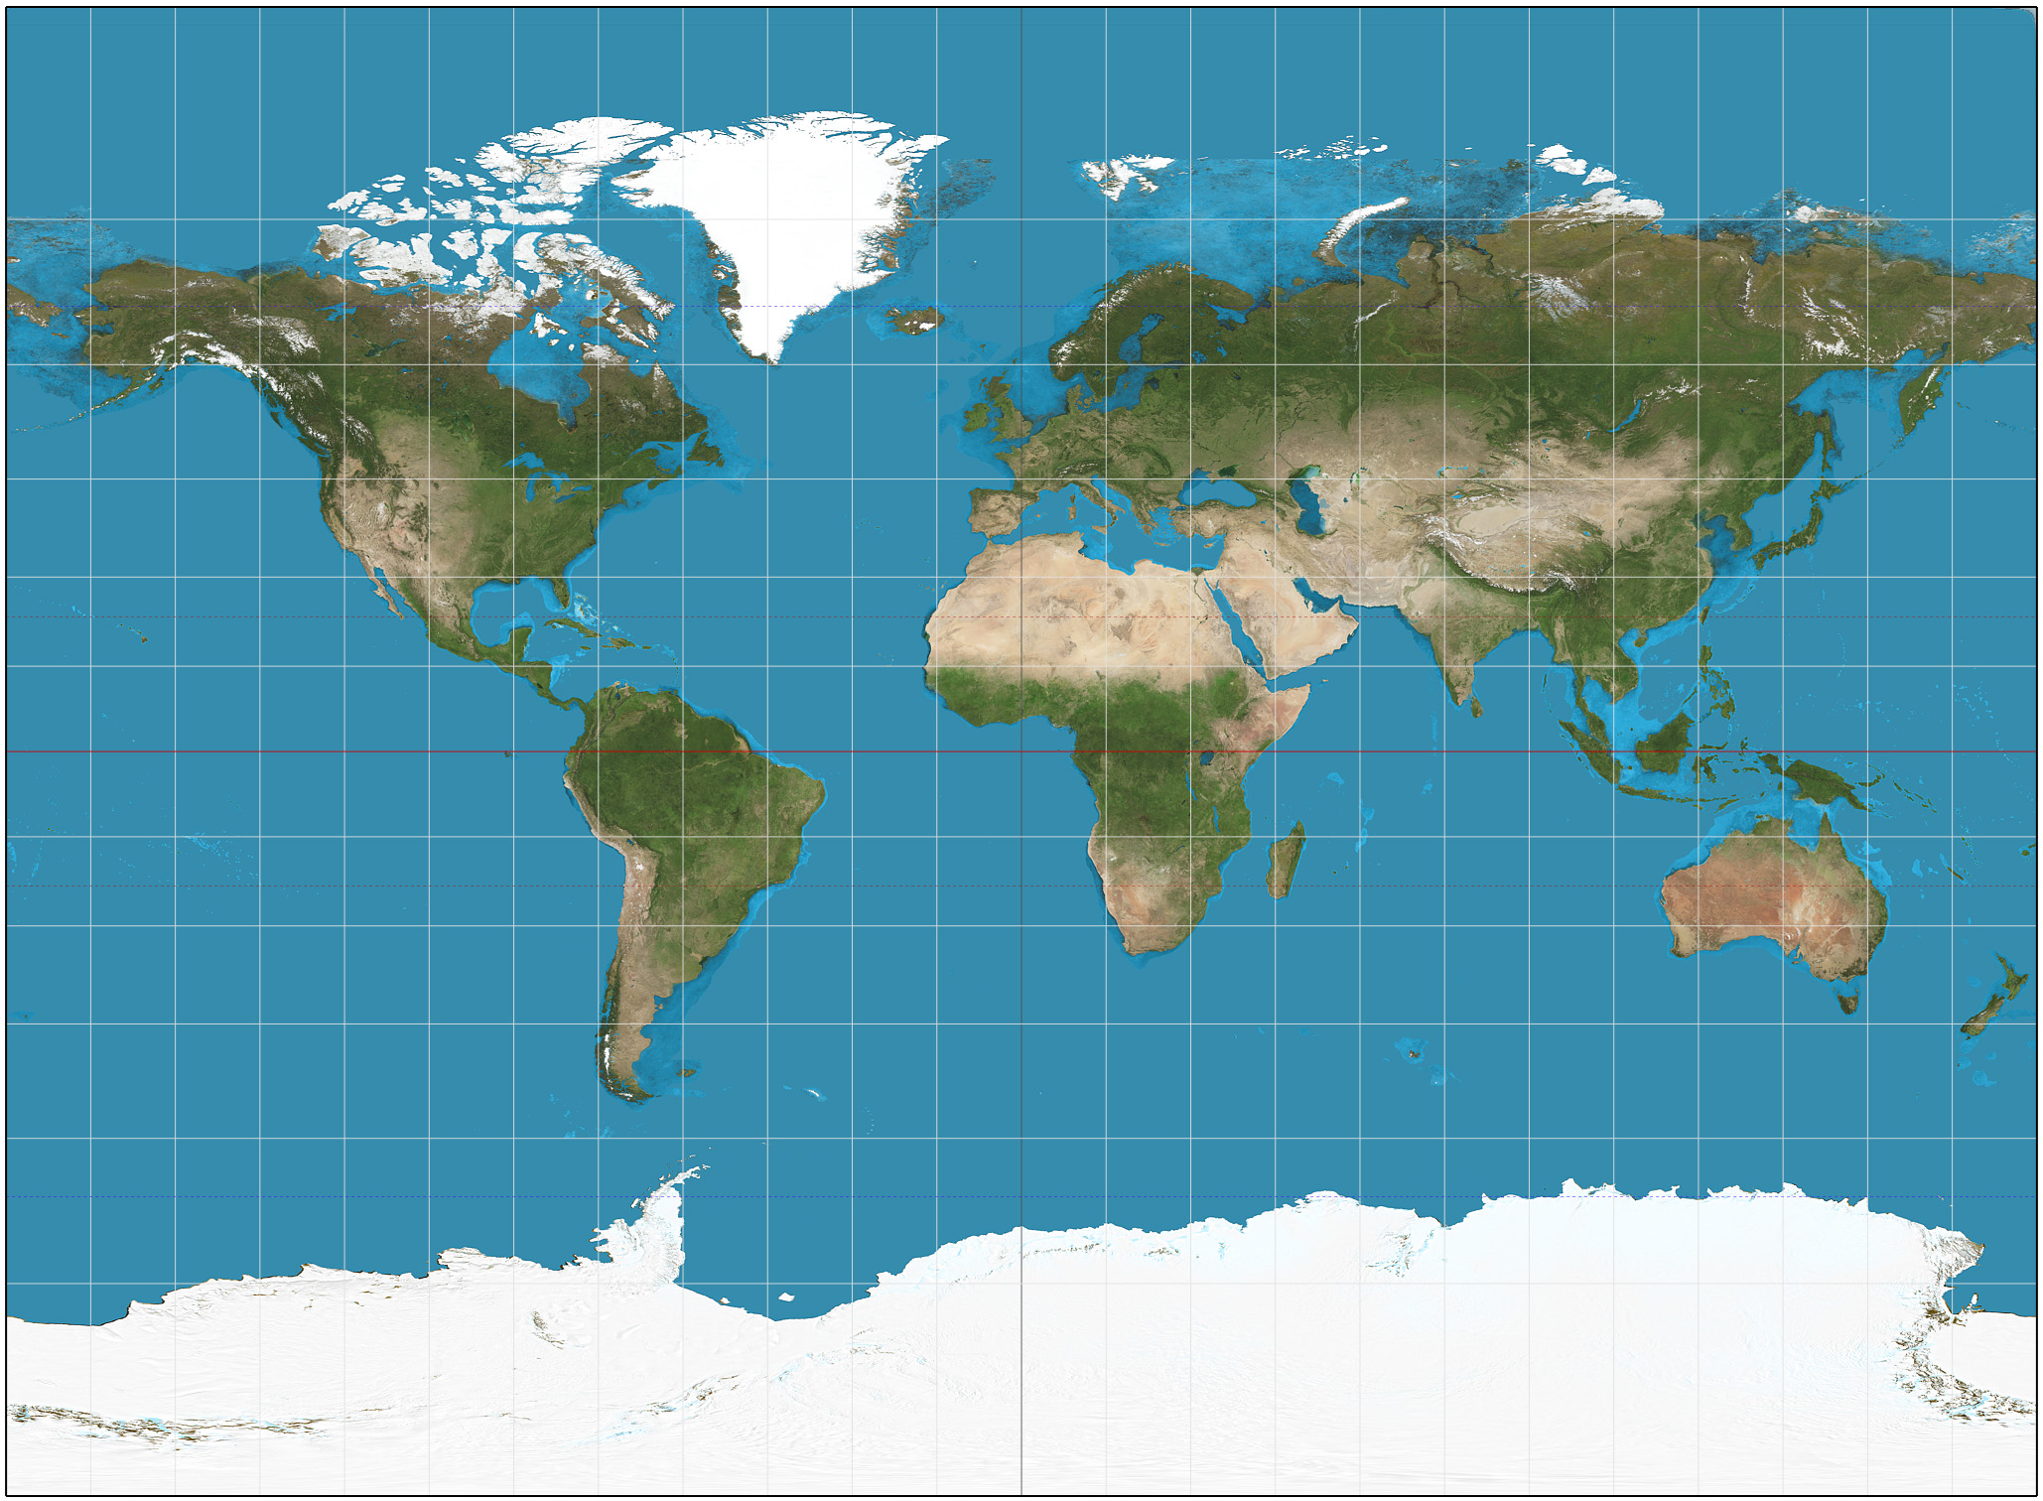

(a)Equirectangular projection (b)Miller projection

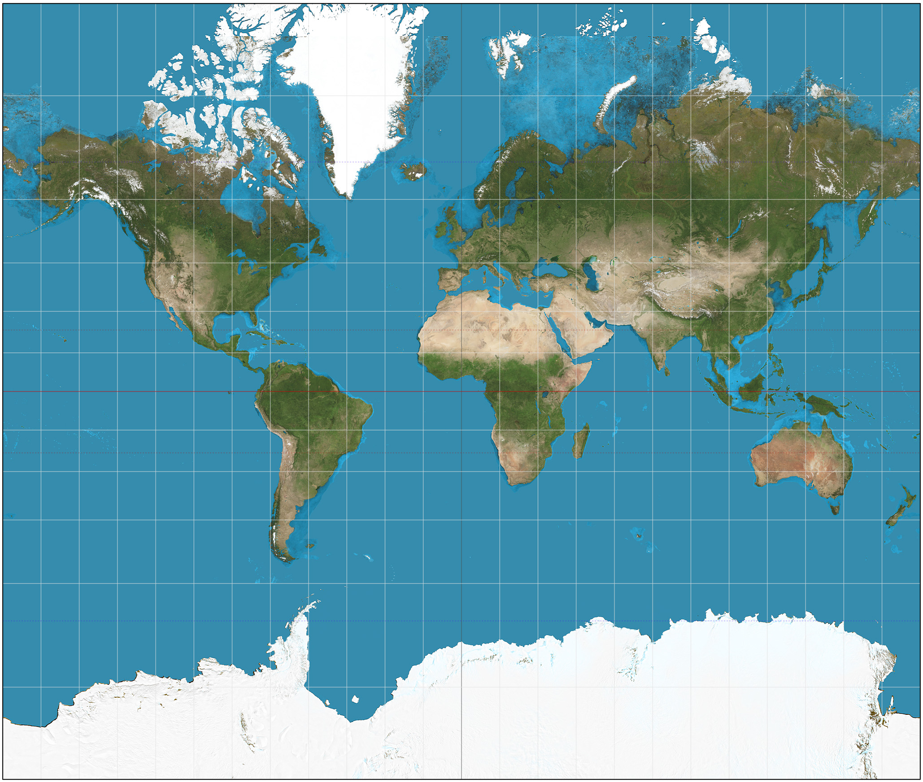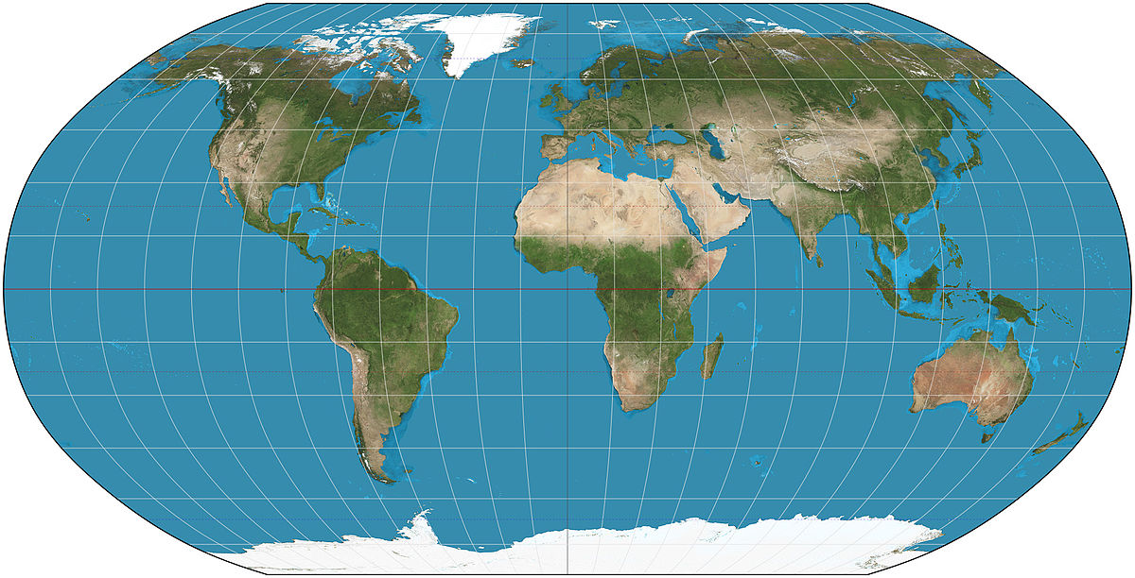

(c)Mercator projection (d)Robinson projection

Fig.16 Examples of maps about four projections

The testing accuracy results of MLPs are shown in Table.7 and Fig.17 below. From the results, we can find that both training accuracy and testing accuracy of the results are all very bad for MLPs with different number of hidden layers. The accuracies are all about 0.25, which is the probability for one class in the four. The predicted value is all for one class. MLPs are not powerful enough to tell the difference between distinct regions.

Table.7 Testing accuracy results of MLPs

|  |  |  |
| --- | --- | --- |
| **# Hidden Layers** | **Training Acc** | **Testing Acc** |
| 2 | 0.25 | 0.24 |
| 3 | 0.25 | 0.26 |
| 4 | 0.25 | 0.25 |

Fig. 17 Testing accuracy results of MLPs

For SVMs, the testing results of four kinds of classification kernel were compared in this experiment. The results are shown in Table.8 and Fig.18 below. According the results, Linear kernel and Polynomial kernel SVMs significantly outperforms the other two. But the testing accuracies are also not good enough for use. They can classify the four classes with relatively satisfactory results, but the other two’s results is very bad. That means that the inner function of region classification fits linear and polynomial kernels to some extent, but it cannot fit RBF and Sigmoid kernels. And we can also find that the training accuracy of RBF kernel is 1, but the testing accuracy is very poor. So, It implies that the RBF kernel overfits the inner function of region classification.

Table.8 Testing accuracy results of SVMs

|  |  |  |
| --- | --- | --- |
| **Kernel Function** | **Training Acc** | **Testing Acc** |
| Linear | 1 | 0.715 |
| RBF | 1 | 0.34 |
| Polynomial | 1 | 0.715 |
| sigmoid | 0.27 | 0.19 |

Fig. 18 Testing accuracy results of SVMs

As for CNNs, the best results are from CNNs with 3 convolutional layers. The best training accuracy can reach 1, but testing accuracy can only reach about 0.8. The general results of CNNs for map identification is shown in Table.9 and Fig.19 below. The CNNs can also get results with high testing accuracy compared with SVMs and MLPs, but the results are not as good as in region classification.

Table.9 Testing accuracy results of CNNs

|  |  |  |
| --- | --- | --- |
| **# Hidden Layers** | **Training Acc** | **Testing Acc** |
| 2 | 1 | 0.75 |
| 3 | 1 | 0.79 |
| 4 | 0.84 | 0.65 |

Fig.19 Testing accuracy results of CNNs

The testing accuracy of best result we got is 95%. The images and corresponding predicted label are shown as follows. The red label of 3 is the wrong predicted label. It should be 0.

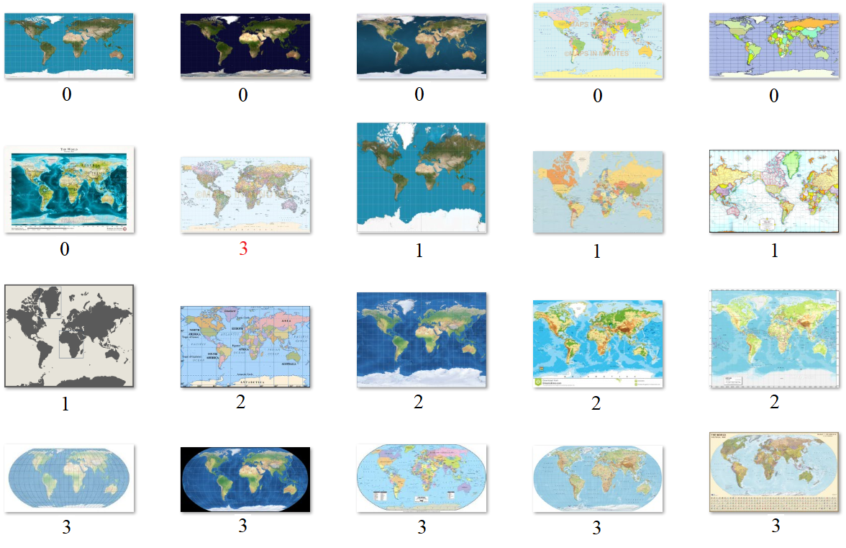

Fig.20 The images and corresponding predicted label

Comparing the experiment results of the three methods, we can find that SVMs and CNNs can also get relatively good classification results with some parameter settings but MLPs cannot get good results. The reason is that is the difference between map images of different projection is much smaller than the difference between map and non-map images and different map regions. Different projections of same region can be very similar for machine to classification. In this case, MLPs cannot tell the difference and get good classification results. CNNs and SVMs can get relatively good results but still not very good.

**Conclusion**

In summary, three machine learning methods were used to solve the map identification, region classification and projection classification problems in this study. In general, CNNs and SVMs can always generate relatively good results and CNNs outperforms SVMs a little bit. For map identification problem, all of the three methods can get good results because of the large difference between map images and non-map images. For region classification and projection classification problems, SVMs and CNNs can also get good results but MLPs’ performance is quite poor. And for projection classification, because of much smaller difference between different projections, even SVMs and CNNs cannot get a testing accuracy above 90%.

This project is the beginning work of AI application for cartography. There are lots of other works to be done here. I will add more types of maps for different regions for map identification. And more parameter settings should be tried for systematically analysis of parameter influence. Additionally, more empirical models for MLPs and CNNs will be tested. All of these works mean to make the conclusion complete and more convincing.

This project can be regarded as the background for further research about AI’s application in cartography and map analysis. Future works include extracting elements of an map image for automatically map digitalization and further analysis and measure the quality of the map from different perspectives.

Reference List

Reference from Rui Li

Reference from Jialin Li

Reference from Ziyu Guo

Reference from Luyu Liu

Ashok, B., & Aruna, P. (2016). Comparison of Feature selection methods for diagnosis

of cervical cancer using SVM classifier. *Int. J. Eng. Res. Appl*, *6*, 94-99.

Ferentinos, K. P. (2018). Deep learning models for plant disease detection and

diagnosis. *Computers and Electronics in Agriculture*, *145*, 311-318.

He, K., Zhang, X., Ren, S., & Sun, J. (2016). Deep residual learning for image

recognition. In *Proceedings of the IEEE conference on computer vision and pattern*

*recognition* (pp. 770-778).

Hughes, D., & Salathé, M. (2015). An open access repository of images on plant health

to enable the development of mobile disease diagnostics. *arXiv preprint*

*arXiv:1511.08060*.

Machin, M., Sanguesa, J. A., Garrido, P., & Martinez, F. J. (2018, April). On the use

of artificial intelligence techniques in intelligent transportation systems.

In *Wireless Communications and Networking Conference Workshops (WCNCW),*

*2018 IEEE* (pp. 332-337). IEEE.

Mohanty, S. P., Hughes, D. P., & Salathé, M. (2016). Using deep learning for image-

based plant disease detection. *Frontiers in plant science*, *7*, 1419.

Oh, S. K., Yoo, S. H., & Pedrycz, W. (2013). Design of face recognition algorithm using

PCA-LDA combined for hybrid data pre-processing and polynomial-based RBF

neural networks: Design and its application. *Expert Systems with*

*Applications*, *40*(5), 1451-1466.

Oleszkiewicz, W., Cichosz, P., Jagodziński, D., Matysiewicz, M., Neumann, Ł., Nowak,

R. M., & Okuniewski, R. (2016, September). Application of SVM classifier in

thermographic image classification for early detection of breast cancer.

In *Photonics Applications in Astronomy, Communications, Industry, and High-*

*Energy Physics Experiments 2016* (Vol. 10031, p. 100312T). International Society

for Optics and Photonics.

Sengorur, B., Koklu, R., & Ates, A. (2015). Water quality assessment using artificial

intelligence techniques: SOM and ANN—A case study of Melen River

Turkey. *Water Quality, Exposure and Health*, *7*(4), 469-490.

Seo, Y., Kim, S., Kisi, O., & Singh, V. P. (2015). Daily water level forecasting using

wavelet decomposition and artificial intelligence techniques. *Journal of*

*Hydrology*, *520*, 224-243.

Sibanda, W., & Pretorius, P. (2011). Novel application of Multi-Layer Perceptrons

(MLP) neural networks to model HIV in South Africa using Seroprevalence data

from antenatal clinics. *International Journal of Computer Applications*, *35*(5).

Silver, D., Schrittwieser, J., Simonyan, K., Antonoglou, I., Huang, A., Guez, A. & Chen,

Y. (2017). Mastering the game of Go without human

knowledge. *Nature*, *550*(7676), 354.

Zhu, X. X., Tuia, D., Mou, L., Xia, G. S., Zhang, L., Xu, F., & Fraundorfer, F. (2017).

Deep learning in remote sensing: a comprehensive review and list of

resources. *IEEE Geoscience and Remote Sensing Magazine*, *5*(4), 8-36.